**RR Format in Dates**

The RR format in Oracle is particularly useful for cases where you have two-digit years, and you want Oracle to determine the century.

**It assumes (default) that the years 00 to 49 are in the current century (2000s), and years 50 to 99 are in the previous century (1900s).**

**Usage of RR 🡪** The RR datetime format element lets you store 20th century dates in the 21st century by specifying only the last two digits of the year.

This format helps to avoid issues with the Y2K problem and is often used in legacy systems or when dealing with historical data.

Create table Data1

(Id int,

BDay Date

);

Insert into Data1 Values(1,'17-Jan-01');

Insert into Data1 Values(2,'28-Mar-74');

Commit;

Select id, to_char(BDay, 'DD-Mon-YYYY') as "Birth Date" from Data1;

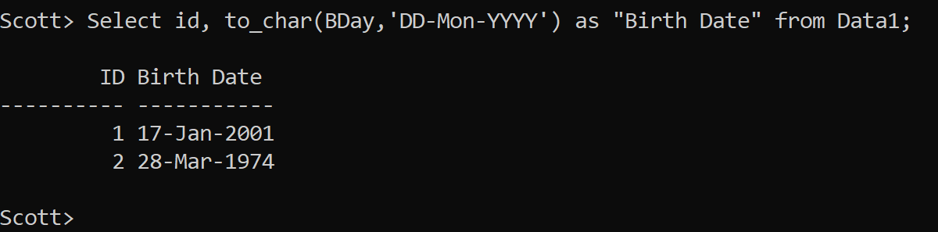

Select id, to_char(BDay, 'DD-Mon-RR') as "Birth Date" from Data1;

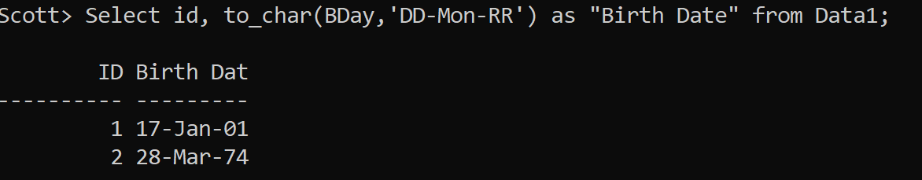

Select id, to_char(BDay, 'DD-Mon-RRRR') as "Birth Date" from Data1;

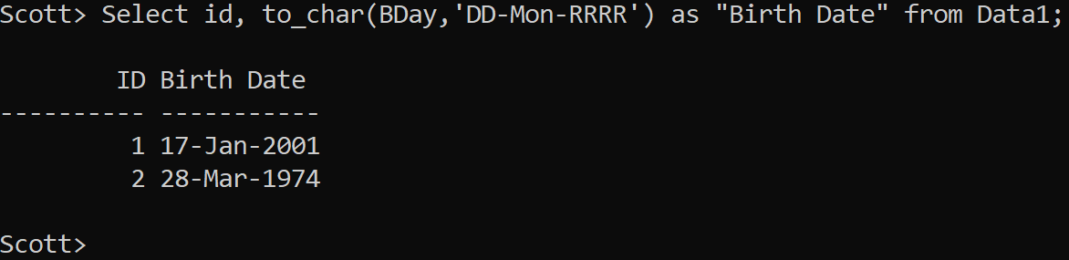

The default behaviour of RR format can create confusion and logical errors in finance, investments and insurance sectors.

create table policy_details

(customer_id int,

policy_maturity_date date);

Insert into policy_details Values(1,'14-Jan-19');

Insert into policy_details Values(2,'27-Jan-53');

Commit;

Column "Policy Maturity Date" Format A30

Select customer_id,

to_char(policy_maturity_date, 'DD-Mon-YYYY') as "Policy Maturity Date" from policy_details;

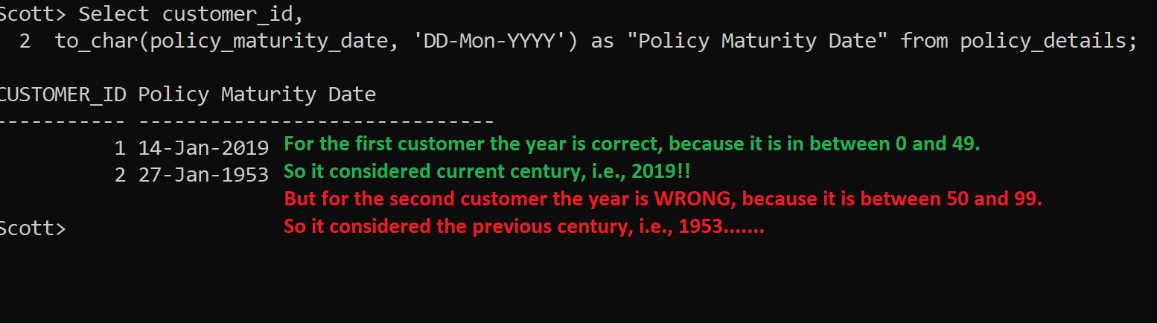

Even the RRRR format will not help.

Select customer_id,

to_char(policy_maturity_date, 'DD-Mon-RRRR') as "Policy Maturity Date" from policy_details;

In such a scenario what is the solution??

Answer 🡪 The first SIMPLE solution is that while entering the dates we MUST enter the complete 4-digit year, so that the century part is safe guarded.

Let’s recreate the table.

drop table policy_details;

create table policy_details

(customer_id int,

policy_maturity_date date);

Insert into policy_details Values(1,'14-Jan-**2019**');

Insert into policy_details Values(2,'27-Jan-**2053**');

Commit;

Select customer_id,

to_char(policy_maturity_date, 'DD-Mon-YYYY') as "Policy Maturity Date" from policy_details;

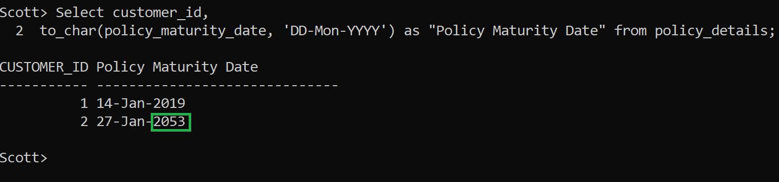

Even if the RRRR format is mentioned still it will be correct.

Select customer_id,

to_char(policy_maturity_date, 'DD-Mon-RRRR') as "Policy Maturity Date" from policy_details;

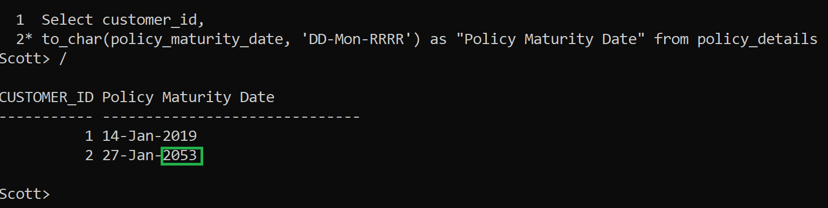

Solution 2:

Or even if the years are mentioned in 2 digits while adding records in the table, still there is another solution.

**Use to_date function inside to_char function.** Then it works fine.

Drop table policy_details;

create table policy_details

(customer_id int,

policy_maturity_date date);

-- Note, while entering dates the year is mentioned in 2-digits only.

Insert into policy_details Values(1,'14-Jan-**19**');

Insert into policy_details Values(2,'27-Jan-**53**');

Commit;

Earlier we were giving the following query:

Select customer_id,

to_char(**policy_maturity_date**, 'DD-Mon-YYYY') as "Policy Maturity Date" from policy_details;

**-- Still not working**

Now, the revised query will be as shown next.

Select customer_id,

to_char(**to_date(policy_maturity_date, 'DD-Mon-YY')**,'DD-Mon-YYYY') as "Policy Maturity Date" from policy_details;

